**AZURE DEVOPS CODING CHALLENGE Q-2**

Q2. Leverage the practices of CICD Using azure Data engineering and explain the architecture of the Azure synapse.

**Continuous integration and continuous deployment (CI/CD):**

Continuous Integration and Continuous Deployment (CI/CD) practices are essential for ensuring the smooth and efficient delivery of data engineering solutions, including those built on Azure Data Engineering services. When implementing CI/CD with Azure Data Engineering, Azure Synapse Analytics, a powerful analytics service, plays a pivotal role.

**CI/CD Practices with Azure Data Engineering:**

**Version Control:** Use version control systems like Git to manage code, configurations, and scripts related to your data engineering solutions.

**Automated Builds:** Automate the build process using tools like Azure Pipelines. Define pipelines that automatically compile, validate, and package your data engineering artifacts.

**Automated Testing:** Implement automated testing to validate the functionality and integrity of your data engineering solutions. This includes unit tests, integration tests, and end-to-end tests.

**Continuous Integration:** Integrate changes from multiple developers into a shared repository frequently. Automate the integration process to detect and address integration issues early.

**Continuous Deployment:** Automate the deployment process to deploy changes to development, staging, and production environments seamlessly. Ensure consistency and reliability in deployments across environments.

**Monitoring and Logging:** Implement monitoring and logging solutions to track the performance, health, and usage of your data engineering solutions. Use Azure Monitor, Azure Log Analytics, and other monitoring services.

**Architecture of Azure Synapse:**

Azure Synapse Analytics is an analytics service that brings together big data and data warehousing. It provides integration with various Azure services to build end-to-end analytics solutions.

The architecture of Azure Synapse Analytics includes the following components:

**SQL Pools**: Azure Synapse Analytics provides dedicated SQL pools (formerly known as SQL Data Warehouses) for running analytical queries. These SQL pools can scale dynamically based on workload requirements.

**Spark Pools:** Azure Synapse Analytics integrates with Apache Spark to provide big data processing capabilities. Spark pools allow you to run Spark jobs for data processing, machine learning, and data exploration.

**Data Integration:** Azure Synapse Analytics offers built-in data integration capabilities for ingesting data from various sources such as Azure Blob Storage, Azure Data Lake Storage, Azure SQL Database, and more.

**Data Orchestration**: Synapse Analytics includes Data Factory integration, enabling you to orchestrate complex data workflows, including data movement, transformation, and scheduling.

**Data Lake Storage:** Azure Synapse Analytics integrates with Azure Data Lake Storage Gen2, providing a scalable and cost-effective storage solution for big data analytics.

**Security and Governance**: Azure Synapse Analytics offers advanced security features such as role-based access control (RBAC), encryption at rest and in transit, and integration with Azure Active Directory for authentication.

**Analytics Services Integration:** Synapse Analytics seamlessly integrates with Azure services like Power BI, Azure Machine Learning, and Azure DevOps for advanced analytics, reporting, and collaboration.

**Implementing Azure Synapse:**

Go to azure portal and select azure synapse. Click on create to create a new azure synapse workspace

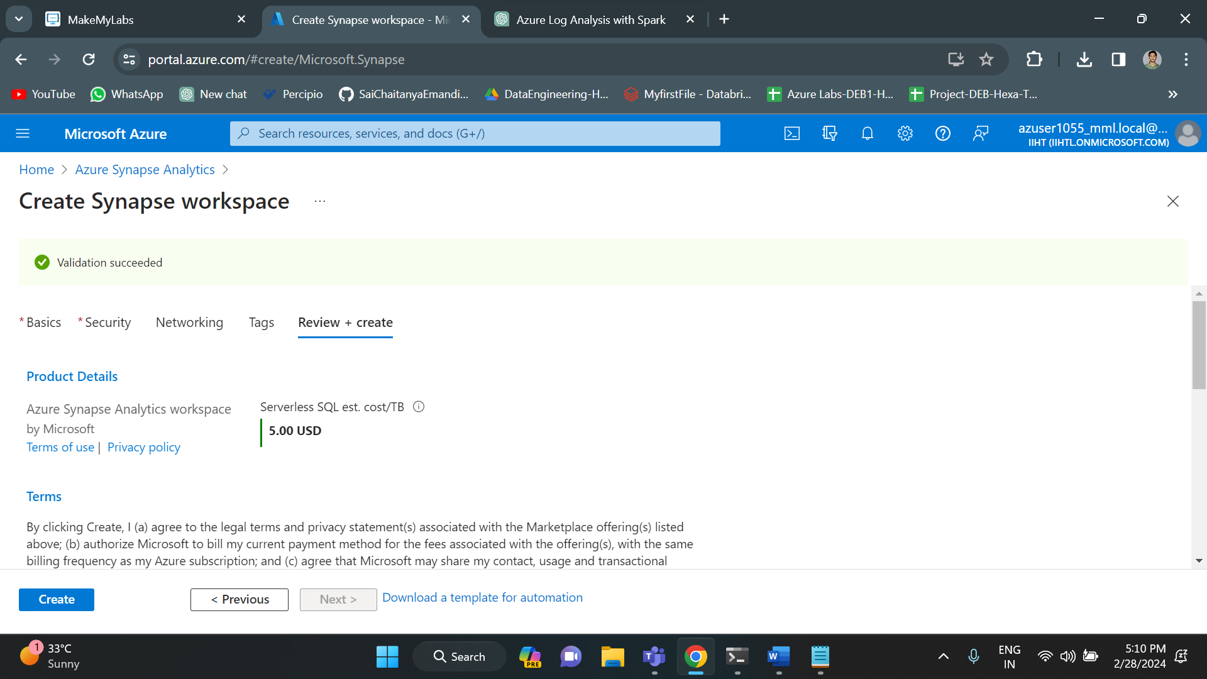

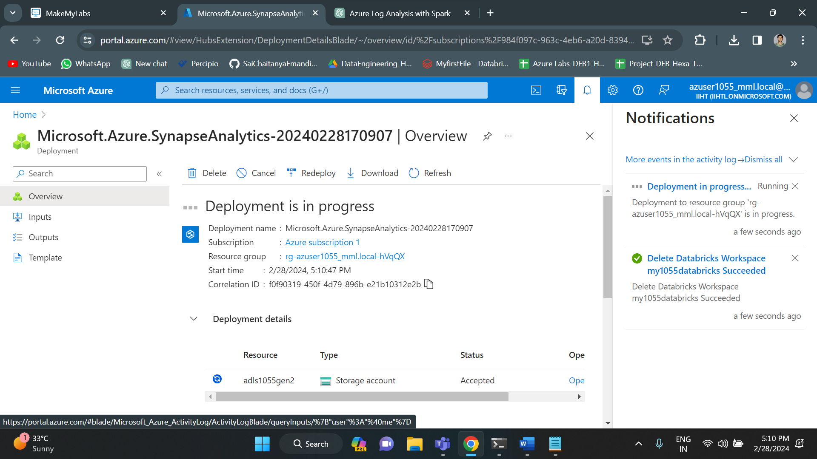

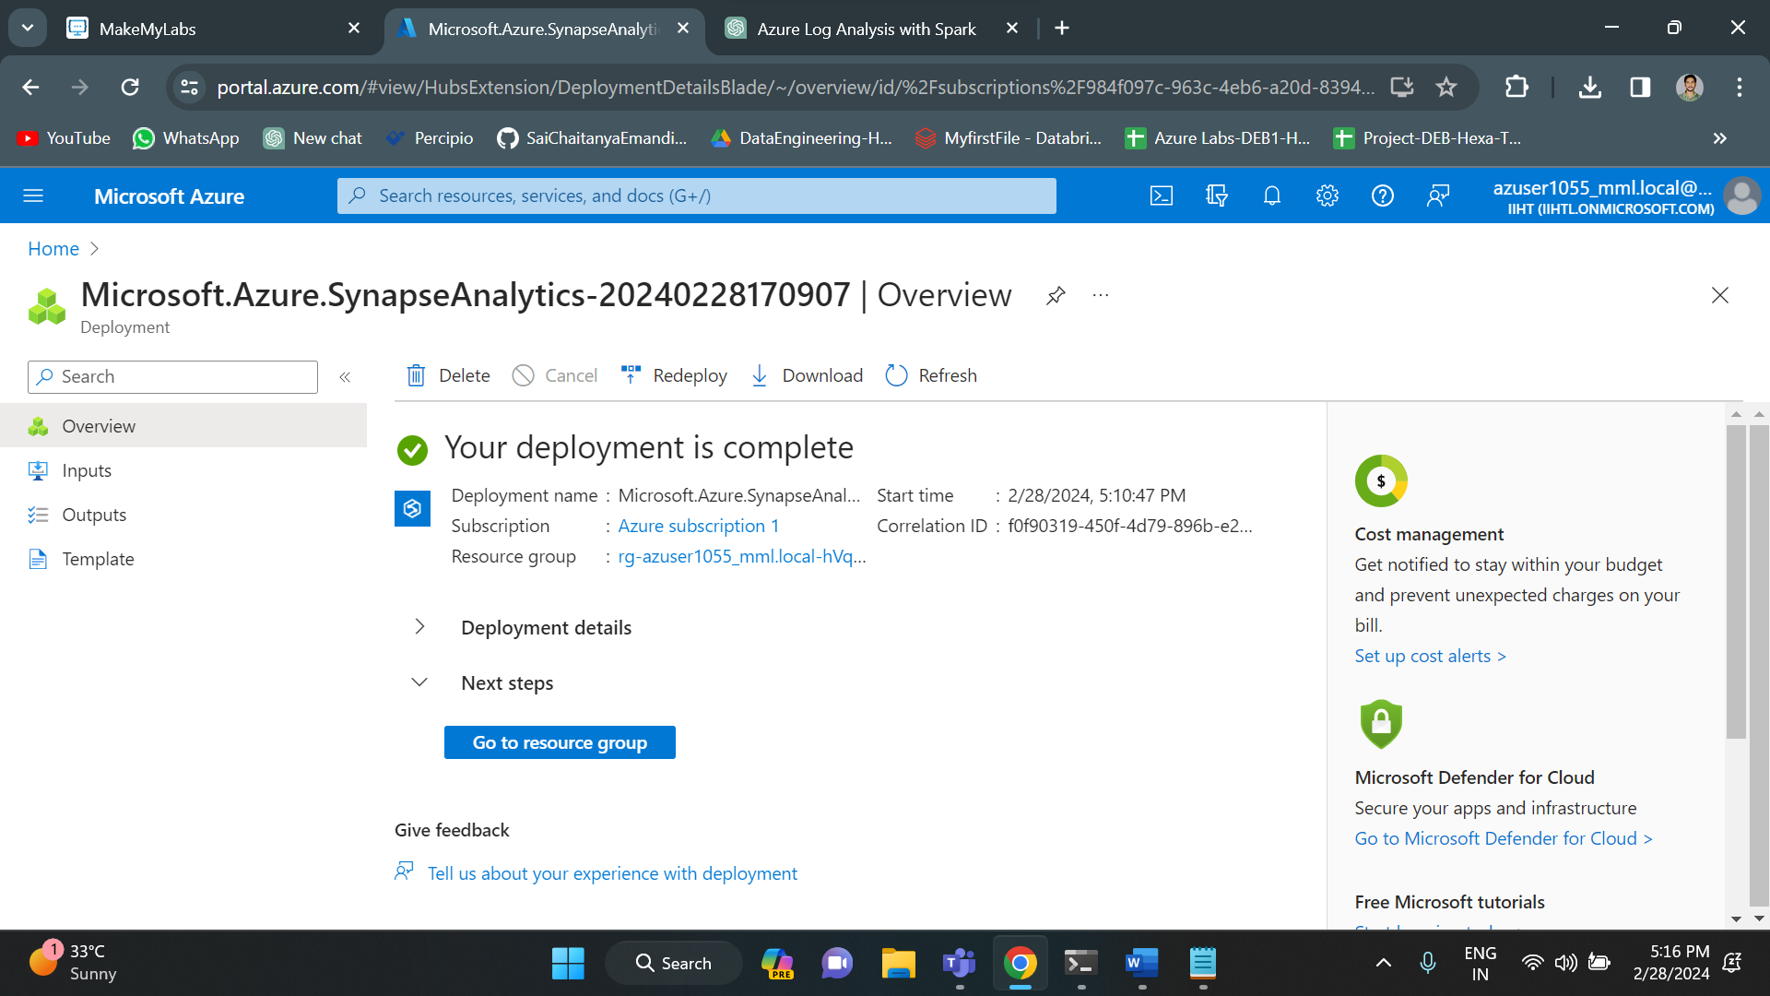

Once the deployment is successful, go to your azure synapse and copy the workspace URL and open in new tab.

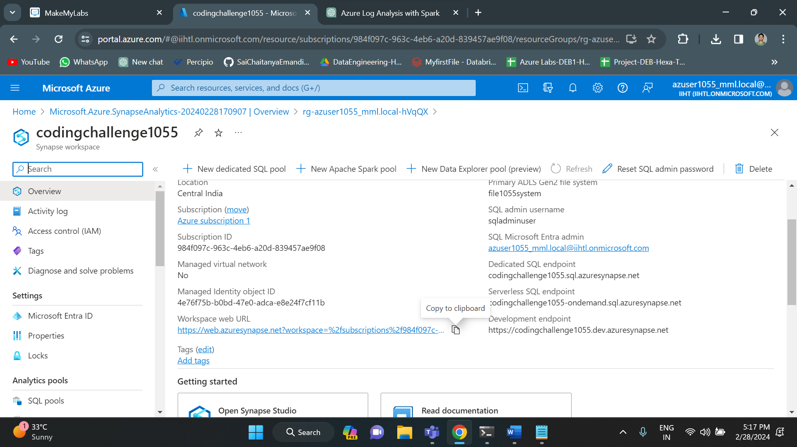

Below is the home of azure synapse workspace.

